Describe Restriction:
(Be specific)
Protocol #: ______________________________________
PI: _____________________________________________

Restriction Start Date: ____________________ Restriction End Date: ___________________________
Contact Name: __________________________ Contact Phone Number: _________________________
(An emergency phone number is required)
Animal ID: ______________________________ Baseline Weight: _______________________________
Date | Total Water Given* | Total Food Given* | Body Weight | Currently restricted? Y/N | Health Observations** | Observer’s Initials

*Ad Lib is acceptable to place in water/food given column if applicable.
**Health observations include whether the animal is dehydrated, Body Condition Score (BCS), lethargic, hair coat quality, etc.

Body Score of Rats from Hickman, D.L., and M. Swan, 2010. Use of a body condition score technique to assess health status in a rat model of polycystic kidney disease. J Am Assoc Lab Anim Sci. 49(2):155-9.
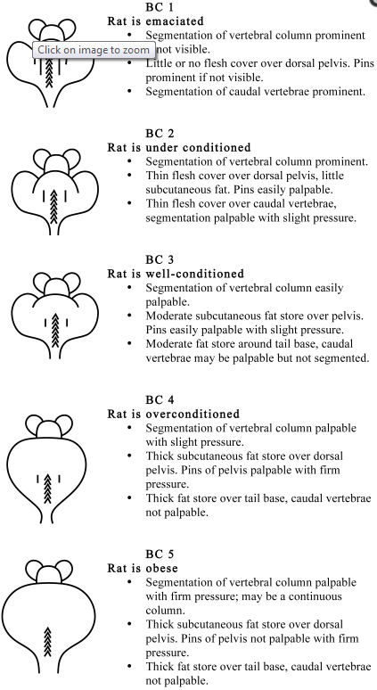
Body Score of Mice from Ullman-Cullere, M. H. and C. J. Foltz, 1999. Laboratory Animal Science. Body Condition Scoring: A Rapid and Accurate Method for Assessing Health Status in Mice. Vol 49, No 3.
