Parameters to be monitored and examples of each (adapted from www.ccac.ca Companion notes)
Appearance:
    - Normal
    - Poor grooming
    - Piloerection, fresh ocular and nasal discharge
    - Piloerection, hunched
    - Eyes half closed

Natural Behavior:
    - Normal
    - Minor change
    - Less mobile and isolated, but alert
    - Restless or very still and not alert

Hydration:
- Water is free flowing
- No piling/crowding around waterer
- Rapid weight loss
- Tacky mucous membranes

Clinical signs:
    - Normal respiration
    - Increased respiration
    - Abdominal breathing
    - Decreased respiration
    - Marked abdominal breathing and cyanosis

Provoked Behavior:
    - Normal
    - Minor depression or exaggerated response
    - Moderate change in expected behavior
    - Very weak
    - Precomatose

Resources:
- http://www.ccac.ca/Documents/Education/Modules/Vivaria/Endpoints/Companion-notes.pdf

- Lloyd and Wolfensohn (1998) Humane Endpoints in Animal Experiments for Biomedical Research. In: Humane Endpoints in Animal Experiments for Biomedical Research, Proceedings of the International Conference, 22-25 November 1998, Zeist, The Netherlands. (Hendricksen C.F.M. and Morton D.S. eds). London UK: Royal Society of Medicine Press, pp.48-53.

- Guidelines for Pain and Distress in Laboratory Animals: Responsibilities, Recognition and Alleviation. From the NIH ARAC: http://oacu.od.nih.gov/ARAC/documents/Pain_and_Distress.pd
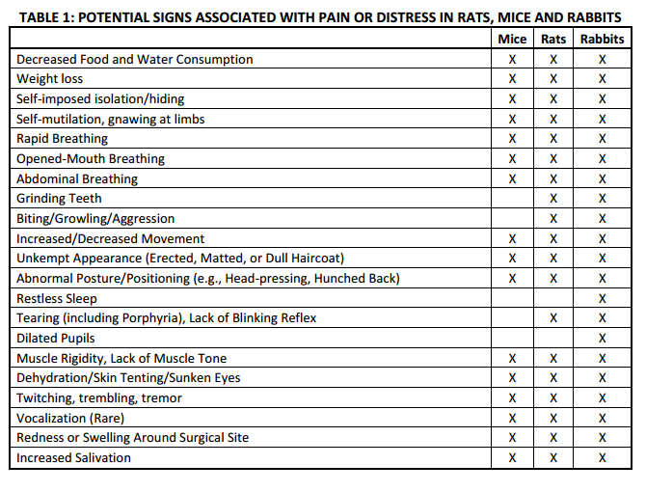
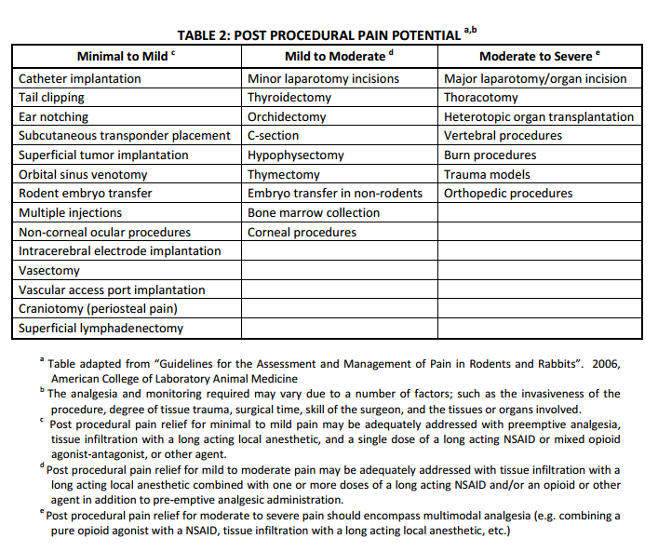

Protocol: ______________________________ PI: ___________________________________
Date | ID | Appearance | Natural Behavior | Hydration | Clinical Signs | Provoked Behavior | Initials
Contact: ______________________________ Phone: _______________________________

